**Requirement Engineering Part**

**I. Domain Understanding:**

HR Management System is a website used to complete some simple transactions using the Internet instead of the paper-based system. The site provides the following services: 1) Request leave or submit a complaint to the manager 2) The daily work schedule in addition to the number of additional hours desired by the employee 3) Inquire about the salary and its value this month 4) Each employee can register with the employee's identification number and password.

**1. Context:**

The system as is takes place of paper based system and it’s objectives. But the website saves Time, Effort and Useability .

**2. Scope of the systems as-is**

This project is beneficial for companies in maintaining employee record. Salary calculation for each employee and also focus on attendance of each employee and the number of leaves taken per month / year. There is also the possibility to check the salary report at any time so as not to lead to any miscalculation.

1. **Stakeholders**

|  |  |
| --- | --- |
| Actor | Interests |
| Managing Director | Salary, Working hours, Job security,  Managing vacation request and reports. |
| Employees | Salary, Working hours, Job security, Vacation request or reports. |
| Company Owners | Business operations to run smoothly, Profit. |
| IT Developer | Create the website, Level of security, Privacy, Data Storage. |

1. **Strengths and Weaknesses of the system as-is**

The Strength Of Paper System Is :

Documentation.

The Weaknesses Of Paper System Is :

1. Prone to damage: Manual documents can be easily damaged, lost, or stolen.
2. Higher costs: Because we will need more paper, printers, copiers, stationery and other office supplies.
3. Lack of security: Paper is one of the biggest information security risks for companies because printed documents can easily be lost, mishandled, or destroyed while digital data can be encrypted and kept securely in hard disks or electronic devices.
4. **Glossary of Terms:**

|  |  |  |
| --- | --- | --- |
| **1** | EIN | Employee Identification Number |
| **2** | HRMS | Human Resource Management System |
| **3** | LMS | Leave Management System |
| **4** | OP | Overtime Pay |

**II. Requirement Elicitation**

*1.*  **Retained Requirement elicitation techniques**

**-** *Which ones?* Questionnaire

*- Motivations?* we can't meet the employee in this time cause of corona virus

For easy access to a larger number of employees and for accurate reports and Asking the employee easily than making and save time also

*2.* **Requirement Elicitations Documents**

**Questionnaire about HR management system**

**Employee information**

|  |  |
| --- | --- |
| Employee id : | Name : |
| Employee job title : | Department : |

**Please encircle only one number from 1-6 that indicates your disagreement or agreement according to your experience and impression about HR management information.**

|  |  |  |  |  |  |  |
| --- | --- | --- | --- | --- | --- | --- |
| **Very Strongly Agree** | **Strongly Agree** | **Agree** | **Disagree** | **strongly Disagree** | **Very Strongly Disagree** |  |
|  |  |  |  |  |  | Employees are regularly informed about the initiatives taken by the HR department |
|  |  |  |  |  |  | In this system , it is clear what belongs to the tasks and what’s outside the field of the HR management information |
|  |  |  |  |  |  | In this system, HR procedures are easy to follow |
|  |  |  |  |  |  | Employees fully understand how HR practice works in the system |
|  |  |  |  |  |  | Top managers believe that HR is the key for development of the institution |
|  |  |  |  |  |  | In general, the HR staff is met with much appreciation in this organization |

Does every employee have enough vacation days ?

Does HR saves time and effort ?

Are manual issues already eliminated in this HR system?

Do you recommended this HR system ?

Do you have privileges?

Please choose one of the following (Agree, disagree, neither agree or disagree)

|  |  |  |  |
| --- | --- | --- | --- |
| Neither agree or disagree | Disagree | Agree |  |
|  |  |  | Organization’s HR executives are fully aware of the business needs and strategies |
|  |  |  | Efforts are taken to generate awareness amongst the employees about the organization’s financial position, customers’ needs, quality of product/service, cost etc |
|  |  |  | The organization’s human resource requirements are systematically ascertained and an appropriate plan is formulated for satisfying the requirements |
|  |  |  | The organization has a formal policy of career planning and development |
|  |  |  | There are distinct career paths and internal promotion norms within the organization |

**III. Requirement Specifications**

**2.2 Software Requirements**

**2.2.1 Functional Requirements**

**Admin:**

|  |  |
| --- | --- |
| Functional | Description |
| Login | Log in using the administrator number and password |
| Change password | The password change or restore |
| Add new employee | The Admin can add a new employee |
| Add attendance dates for employees | The Admin can add working time for employees |
| Accept or reject holiday or leave | The Admin can approve or deny a holidays or leave To the employee with the reason written |
| Calculate the salary | The Admin can Calculate the salary To the employee |
| view employee review | The Admin can view and respond to employee feedback |

**Employee:**

|  |  |
| --- | --- |
| Functional | Description |
| login | Log in using the employee number and password |
| Change password | The password change or restore |
| Request holiday or leave | Employees are allowed to request holiday or leave |
| Writ a complaint or a note to the director | Employees are allowed to submit a complaint or note to the manager |
| view work time | Employees are allowed to view working hours |
| view the salary | Employees are allowed to view the salary amount |
| Admin reviews | It allows employees to view the manager's notes |

**2.2.2 Non Functional Requirements**

Usability: the system is easy to use by the users, we tried to provide easy control interfaces in the design.

**IV Requirements Analysis**

The requirement was read and it was clear and understandable and there is no ambiguity in it and it was easy to apply and it was dealt together with all transparency

**V. Requirements Validation**

|  |  |  |  |
| --- | --- | --- | --- |
|  | **Question** | **Yes** | **No** |
| **1** | Does it possible to implement all of the requirements? | Yes |  |
| **2** | Is the maintainability of the system/software specified?  Including the ability to respond to changes in the operating environment, interfaces, accuracy, performance, and additional predicted capabilities. |  | No |
| **3** | Have requirements for communication among system/software components been specified? | Yes |  |
| **4** | Have overall function and behavior of the system/software been defined? | Yes |  |
| **5** | Is the maximum memory specified? |  | No |
| **6** | Do the requirements define all the information that is to be displayed to the user? | Yes |  |
| **7** | Are there conflicting requirement? |  | No |
| **8** | Is each requirement testable? | Yes |  |
| **9** | Is the level of security specified? | Yes |  |
| **10** | Have the software and hardware environments been defined? | Yes |  |
| **11** | Are the specified error messages unique and meaningful? | Yes |  |
| **12** | Is each requirement in scope for the project? | Yes |  |

**VI. Requirement Modeling**

**Use case:**

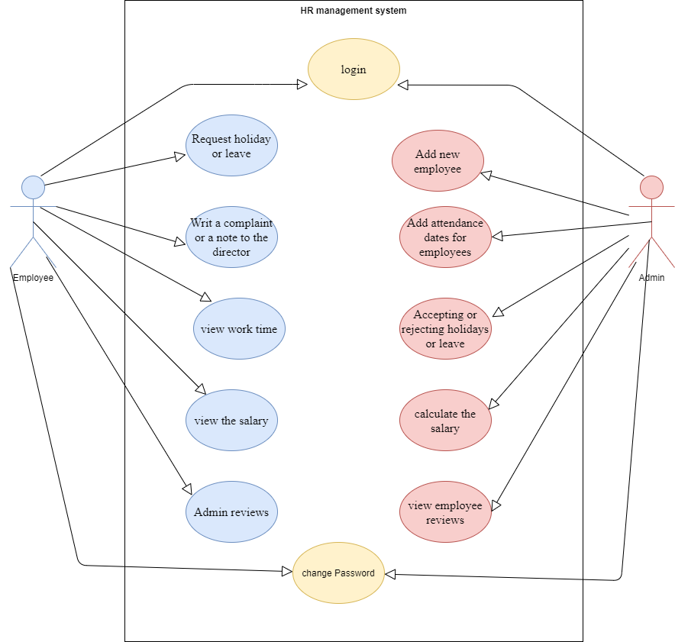

**Class diagram:**

